Update September 2022

Hi everyone – After a bit of a lull BDA cttee have finalised some new workshops for you. Please let Terry know if you hope to attend terrywright@btinternet.com

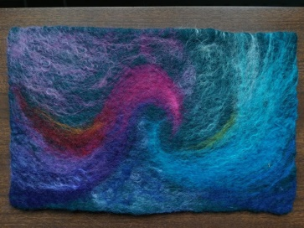
Wet Felting 17 Sept with Georgina Johnson 10 – 4 Mettingham VH - £15 including materials

NEEDLE FELTING with Becky Whatling 15 Oct 10 – 1 Mettingham VH - £20 incl materials
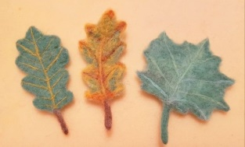
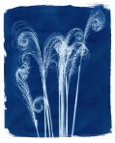
Cyanotype at Martons, Frary Place, Beccles R, Bungay NR35 1HO with Mary Sprake 22 October 11 – 3 £25 inc materials
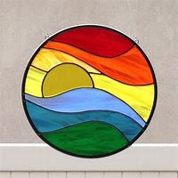
STAINED GLASS WITH Teri Lockton 19 November 9 – 5 Mettingham Village Hall Lantern or sun catcher (state which when booking). £40 inc materials
AGM Sun 16 October 3pm Mettingham VH

STILL ONGOING ARE:
Mondays 2 – 4.30 Art Class with Di McKenna @ MVH £14 per session
3rd Wed in the month – Printing with Jackie Linney 10 – 3 MVH £35 per session
To book your place on any of the above or register an interest please contact terrywright@btinternet.com

